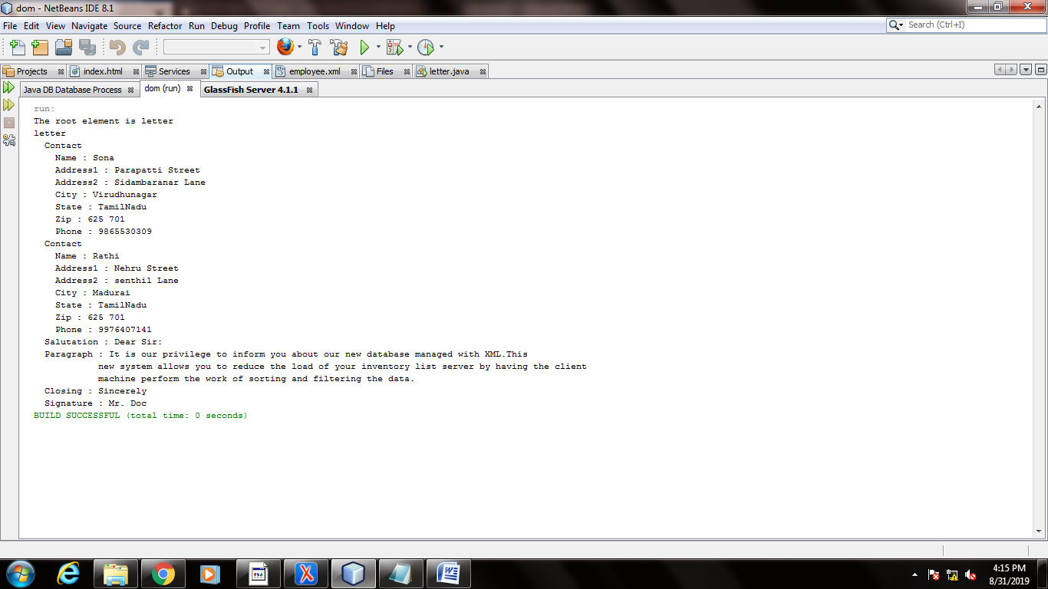

Employee.xml

<?xml version="1.0" encoding="UTF-8"?>

<!--

To change this license header, choose License Headers in Project Properties.

To change this template file, choose Tools | Templates

and open the template in the editor.

-->

<letter>

<contact>

<name>Sona</name>

<address1>Parapatti Street</address1>

<address2>Sidambaranar Lane</address2>

<city>Virudhunagar</city>

<state>TamilNadu</state>

<zip>625 701</zip>

<phone>9865530309</phone>

</contact>

<contact>

<name>Rathi</name>

<address1>Nehru Street</address1>

<address2>senthil Lane</address2>

<city>Madurai</city>

<state>TamilNadu</state>

<zip>625 701</zip>

<phone>9976407141</phone>

</contact>

<body>

<salutation>Dear Sir:</salutation>

<paragraph>It is our privilege to inform you about our new database managed with XML.This

new system allows you to reduce the load of your inventory list server by having the client

machine perform the work of sorting and filtering the data.</paragraph>

<closing>Sincerely</closing>

<signature>Mr. Doc</signature>

</body>

</letter>

Letter.java

/*

* To change this license header, choose License Headers in Project Properties.

* To change this template file, choose Tools | Templates

* and open the template in the editor.

*/

/**

*

* @author 17UITE027

*/

import org.w3c.dom.*;

import javax.xml.parsers.*;

import java.io.*;

import java.util.logging.Level;

import java.util.logging.Logger;

import org.xml.sax.SAXException;

public class letter {

public static void main(String args[]) throws ParserConfigurationException,IOException,SAXException{

DocumentBuilderFactory factory = DocumentBuilderFactory.newInstance();

DocumentBuilder builder = factory.newDocumentBuilder();

Document document = builder.parse(new File("C:\\Users\\17uite027\\Documents\\NetBeansProjects\\dom\\src\\java\\employee.xml"));

document.getDocumentElement().normalize();

Element root = document.getDocumentElement();

System.out.println("The root element is " +root.getNodeName());

System.out.println(root.getNodeName());

NodeList nList = document.getElementsByTagName("contact");

for (int temp = 0; temp < nList.getLength(); temp++)

{

Node node = nList.item(temp);

if (node.getNodeType() == Node.ELEMENT_NODE)

{

System.out.println(" Contact");

Element eElement = (Element) node;

System.out.println(" Name : " + eElement.getElementsByTagName("name").item(0).getTextContent());

System.out.println(" Address1 : " + eElement.getElementsByTagName("address1").item(0).getTextContent());

System.out.println(" Address2 : " + eElement.getElementsByTagName("address2").item(0).getTextContent());

System.out.println(" City : " + eElement.getElementsByTagName("city").item(0).getTextContent());

System.out.println(" State : " + eElement.getElementsByTagName("state").item(0).getTextContent());

System.out.println(" Zip : " + eElement.getElementsByTagName("zip").item(0).getTextContent());

System.out.println(" Phone : " + eElement.getElementsByTagName("phone").item(0).getTextContent());

}

}

NodeList nLists = document.getElementsByTagName("body");

for (int temp = 0; temp < nLists.getLength(); temp++)

{

Node node = nLists.item(temp);

if (node.getNodeType() == Node.ELEMENT_NODE)

{

Element eElement = (Element) node;

System.out.println(" Salutation : " + eElement.getElementsByTagName("salutation").item(0).getTextContent());

System.out.println(" Paragraph : " + eElement.getElementsByTagName("paragraph").item(0).getTextContent());

System.out.println(" Closing : " + eElement.getElementsByTagName("closing").item(0).getTextContent());

System.out.println(" Signature : " + eElement.getElementsByTagName("signature").item(0).getTextContent());

}

}

}

}